Designing and Building Software

Project 1 – Obtaining Visual Studio

November 7, 2018

Video Notes

1. Visual Studio Community Edition is available for free at https://visualstudio.microsoft.com/vs/community/: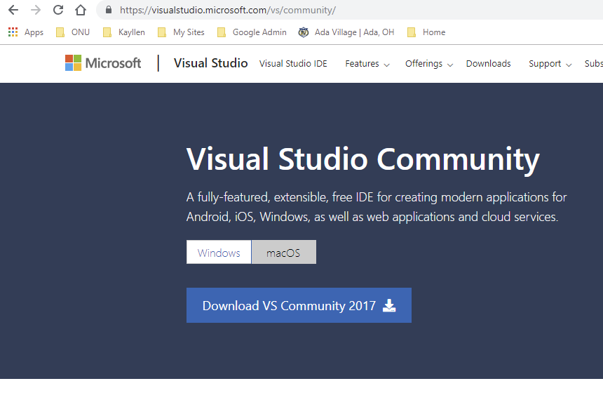
2. Click on the button "Download VS Community 2017" and follow the directions to install the application. It is quite large and depending on your computer and your internet connection may take quite a while to download. It is worth the wait.
3. Run the application as you do any other. I find it helpful to pin the application icon on the task bar.